**Frida server in phone and pc**

Install python in Pc

<https://www.python.org/ftp/python/3.7.4/python-3.7.4-amd64.exe>

put python in platform file

open cmd and go in python/script folder

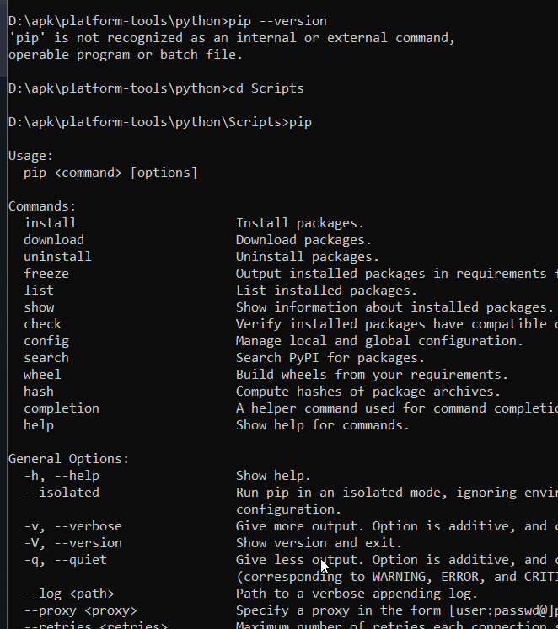

**install Frida server in system (windows)**

pip install frida-tools=1.2.2

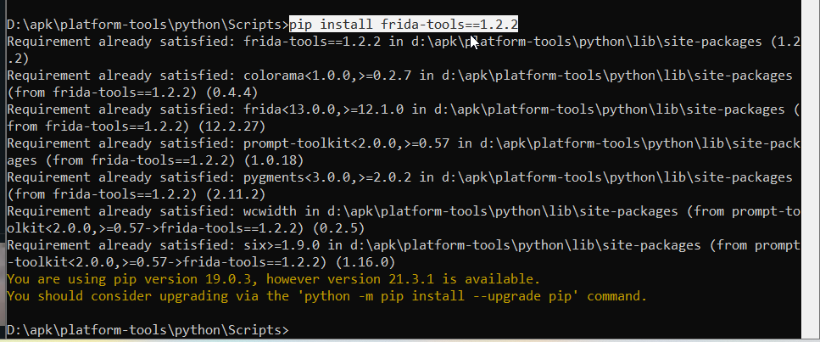

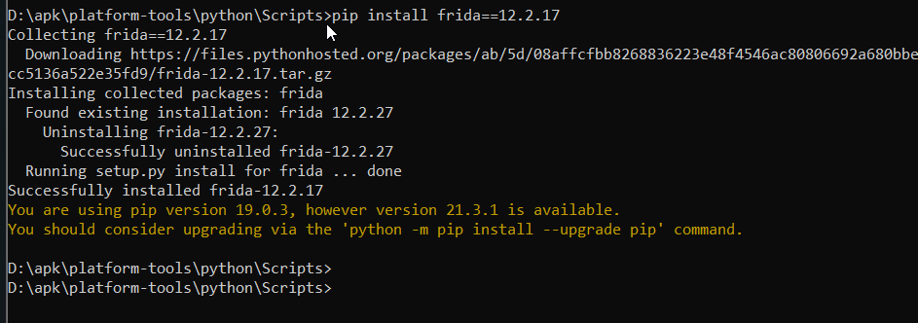**pip install frida==12.2.17**

now download Frida for android device

[Release Frida 12.6.10 · frida/frida · GitHub](https://github.com/frida/frida/releases/tag/12.6.10)

Download this and do **(ADB push in /data/local/tmp)**

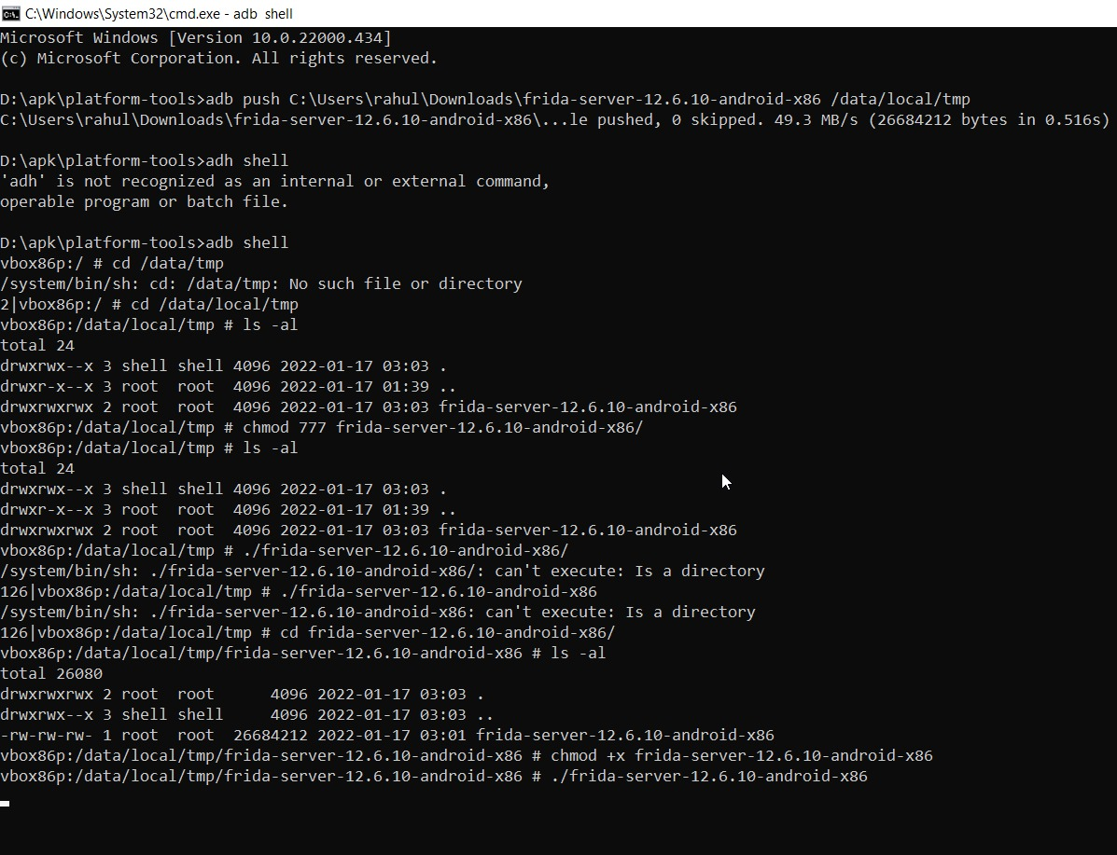

After successful adb push open **(adb shell)**

Go to /data/local/tmp and give **execution permission** on Frida folders

After giving permission execute Frida file

**Code**: ./Frida

To check Frida is properly running on android use this command in cmd

**Code**: frida-ps -U

